Lab Experiment: Image Processing Operations
Experiment No: 14
Aim
To perform image transformation using a Homography Matrix in Python with the OpenCV library.
Tools Required
- Python 3.x
- OpenCV (cv2)
- NumPy
- VS Code / PyCharm / Jupyter Notebook
- Input Image (e.g., image.jpg)
Procedure
- Install the required libraries:
pip install opencv-python numpy
- Import the required libraries (cv2 and numpy).
- Read the input image using cv2.imread().
- Define four corresponding source and destination points.
- Compute the Homography Matrix using cv2.findHomography().
- Apply the transformation using cv2.warpPerspective().
- Display both the original image and the transformed image.
- Press any key to close the windows.
Code
import cv2
import numpy as np
# Read the image
image = cv2.imread("sample.jpeg")
# Get image dimensions
h, w = image.shape[:2]
# Source points
src_pts = np.float32([
[50, 50],
[w - 50, 50],
[50, h - 50],
[w - 50, h - 50]
])
# Destination points
dst_pts = np.float32([
[0, 0],
[w, 50],
[50, h],
[w - 50, h - 50]
])
# Compute Homography Matrix
H, status = cv2.findHomography(src_pts, dst_pts
# Apply Homography Transformation
output = cv2.warpPerspective(image, H, (w, h))
# Display images
cv2.imshow("Original Image", image)
cv2.imshow("Homography Transformation", output)
cv2.waitKey(0)
cv2.destroyAllWindows()
Output
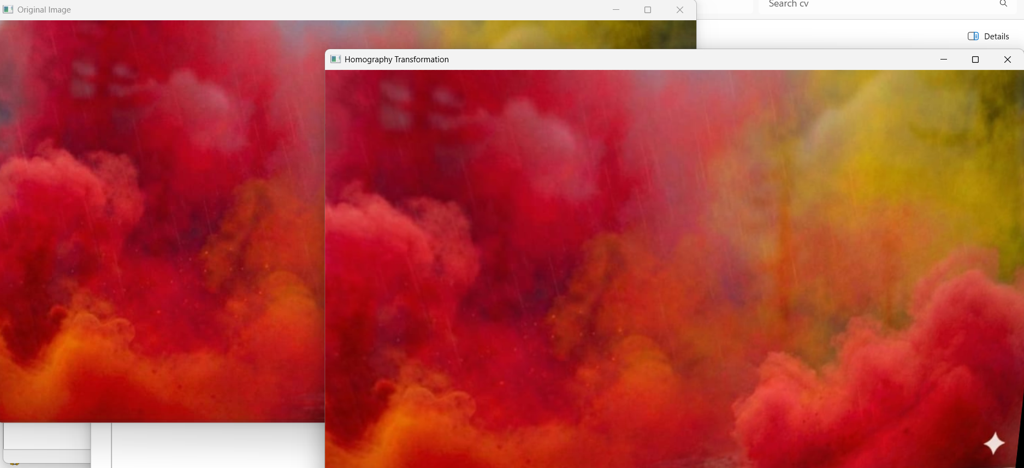
Result
The input image was successfully transformed using a Homography Matrix in Python with the OpenCV library. The transformed image was displayed successfully.

